Name: Andrew Duong

Date: 10-08-2020

Team: Bluetooth Hydrometer Team

Individual work performed on planned tasks this period:

|  |  |  |  |
| --- | --- | --- | --- |
| Task Description | Planned Work (work units) | Actual Work (work units) | % Complete |
| Demo ListView Functionality in Android App | 1 | 1 | 100 |
| Store Temperature and Specific Gravity in ListView using a String Array | 0.8 | 1 | 125 |

Individual work planned for next period:

|  |  |  |
| --- | --- | --- |
| Task Description | Date Due | Planned Work (work units) |
| Demo Field Entry in an Android App | 10/16/2020 | 1 |
| Use Field Entry to add Strings of Temperature and SG to ArrayList of Strings | 10/20/2020 | 0.33 |

Individual work performed on unplanned tasks this period:

|  |  |
| --- | --- |
| Task Description | Actual Work (work units) |
| Store Temperature and Specific Gravity in ListView using an ArrayList of Strings | 1 |

List any problems encountered or unresolved issues:

I have some issues adding elements of Strings to an ArrayList when I was converting my app from using String Arrays to ArrayList of String for the ArrayAdapter in ListView for the Android app.

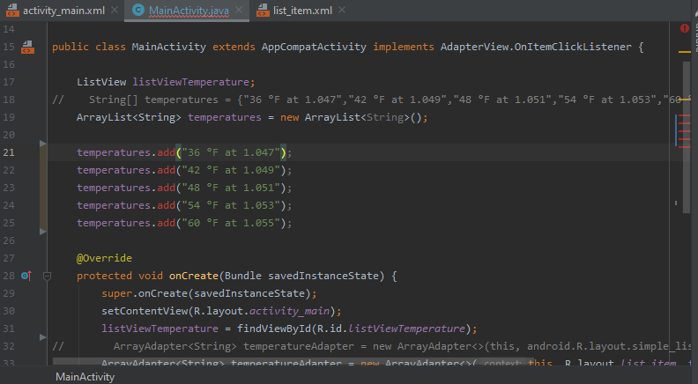 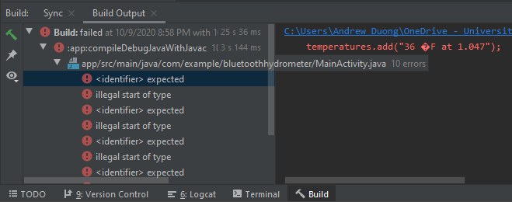

It was simply Syntax errors with ArrayList in Java. I can’t add to an ArrayList within a *class*, it has to be done within a *method*.

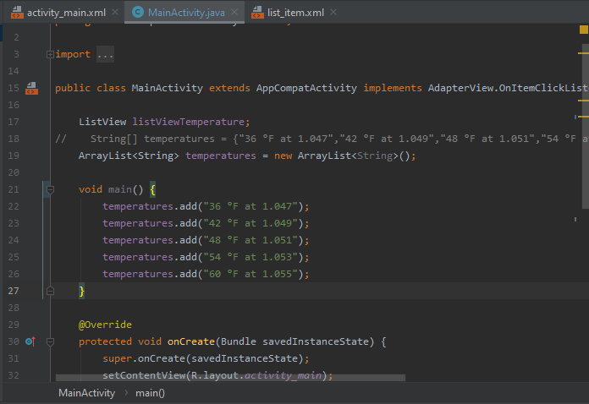 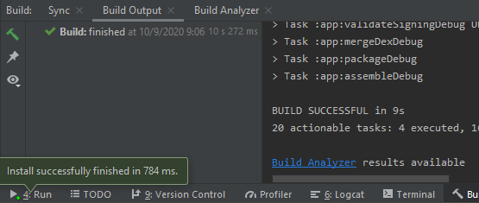

Unfortunately, by me calling the add methods inside the main method, the app refuses to add the data to ListView.

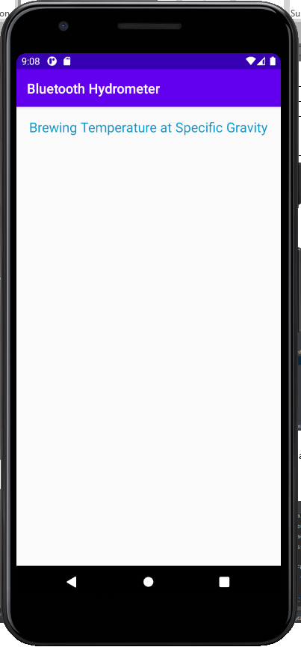

By creating a method and calling it correctly in the onCreate method, I was able to add the data properly to ListView. Therefore, the app performed exactly as I needed to with ArrayList of Strings as it normally would with String Arrays.

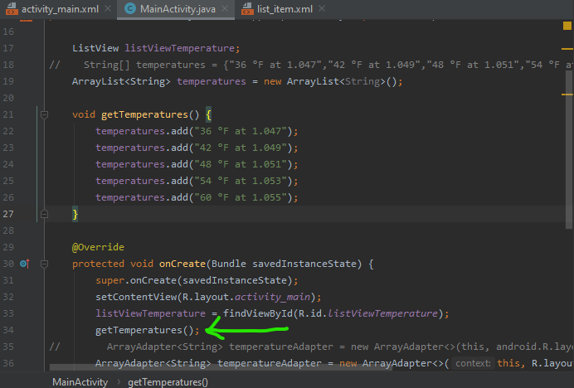 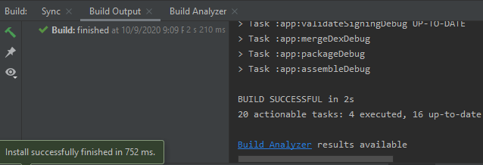

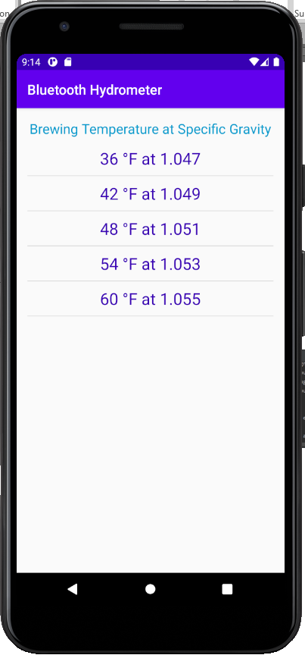

List any key lessons learned: